4. What do I do with my eyes?
When one is serving, eyes should always be focused on the action at the altar, on the reader, or on the presider. It is very distracting to have a server staring into the Mass looking any where or at the ceiling. If you do not know where to look, keep your eyes lowered and look at the floor.

The Vesting of Servers
Those who serve at the altar regularly vest in cassock or Sultana and cotta or surplice. The cassock, worn over street clothes, should be of such length as to come to the top of the shoes. Wear the white cotta over the cassock

Neatness is always in order: combed hair, clean shoes, clean hands and fingernails. Remember, your appearance should not distract the Mass.

Always be vested fifteen minutes before the service is to begin. This will leave you time for last minute preparations and instructions.

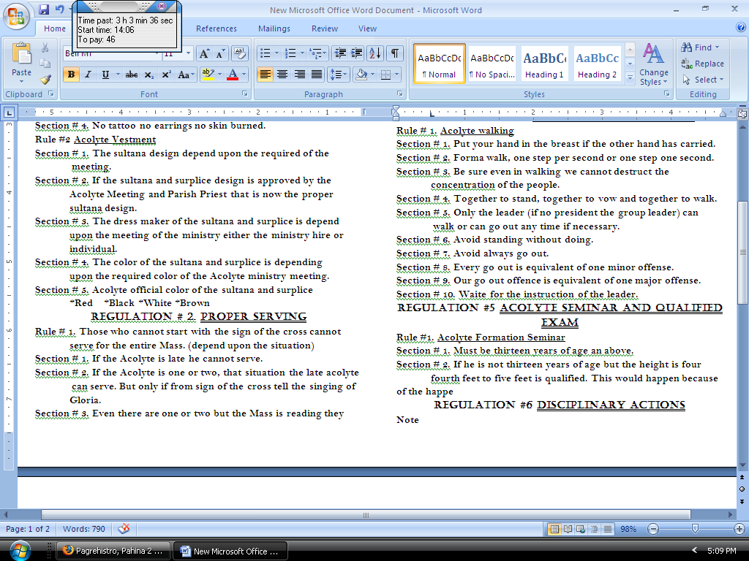

ACOLYTE MINISTRY
St John Neumann Parish
Sicayab Dipolog City

RULES AND REGULATION
Regulation #1 Proper Uniform
Rule #1 Acolyte posture
Section #1. Black shoes back pants black or white T-shirt. The
other Color of shoes pants and socks is not required.
T-shirt is not strictly required because the Acolyte Ministry
give a right to chose to their t-shirt.
Section # 2. Sultana should be clean and plane.
Section # 3. Proper hair cut. 1or 2 inc. and the side wall should be
Cut. Depend upon the order of the meeting about hair
cut uniform.
Section # 4. No tattoo no earrings no skin burned.
Rule #2 Acolyte Vestment
Section # 1. The sultana design depend upon the required of the
meeting.
Section # 2. If the sultana and surplice design is approved by the
Acolyte Meeting and Parish Priest that is now the proper
sultana design.
Section # 3. The dress maker of the sultana and surplice is depend
upon the meeting of the ministry either the ministry hire or
individual.
Section # 4. The color of the sultana and surplice is depending
upon the required color of the Acolyte ministry meeting.
Section # 5. Acolyte official color of the sultana and surplice
*Red *Black *White *Brown
Regulation # 2. Proper Serving
Rule # 1. Those who cannot start with the sign of
the cross cannot serve for the entire Mass.
(depend upon the situation)
Section # 1. If the Acolyte is late he cannot serve.
Section # 2. If the Acolyte is one or two, that situation
the late acolyte
can serve. But only if from sign of the cross tell
the singing of Gloria.
Section # 3. Even there are one or two but the Mass is in
reading they cannot serve the late server.

Rule #2. Be on time to have a task to be
assigned in the Mass.
Section # 1. One to thirty min. before the mass in the
arrival.
Regulation #3 Before the service
Rule #1. Prepared all the mass kit or Mass needed.
Section # 1. Be on time to have a greater time to consume to prepare
the Mass.
Section # 2. Twenty to fifteen min. before the mass is the time limit to secure every body is prepared.
Section # 3. Fifteen min. before the mass every body should wear
their vestment and hair should be comb.
Section # 4. Teen min. before the mass all materials to be needed used
in the mass is prepare in the entrance door.
Regulation # 4 Uniformity of actions
Rule # 1. Acolyte walking
Section # 1. Put your hand in the breast if the other hand has carried.
Section # 2. Forma walk, one step per second or one step one second.
Section # 3. Be sure even in walking we cannot destruct the
concentration of the people.
Section # 4. Together to stand, together to vow and together to walk.
Section # 5. Only the leader (if no president the group leader) can
walk or can go out any time if necessary.
Section # 6. Avoid standing without doing.
Section # 7. Avoid always go out.
Section # 8. Every go out is equivalent of one minor offense.
Section # 9. Our go out offence is equivalent of one major offense.
Section # 10. Waite for the instruction of the leader.

Regulation #5 Acolyte Seminar and qualified exam
Note
During the seminar they cannot go home if
there is no
permeation from the leader or Acolyte
President.

Rule #1. Acolyte Formation Seminar
Section # 1. Must be thirteen years of age an above.
Section # 2. If he is not thirteen years of age but the
height is four fourth feet to five feet is qualified.
This would happen because of the same happen
of the last batch of seminar; the ministry
hired from teen and above years old but the
attitude of the last batch is not qualified to
become an ACOLYTE. The thirteen years
old have their own understanding of what is
their purpose for.
Section #3. The trainer coordinator and the elected
Acolyte President has a power to hire or not to
hire or re-hire if the certain person applied for
acolyte is not qualified. Depend upon the both
parties.
Rule # 2. Qualifying Exam
Section #1. This is to certify that the acolyte is
absolutely know their functions.
Section #2. Exam is the greater challenge to study about
the faith and their functions for.
Section # 3. The Junior Acolyte is from thirteen to
eighteen years of age. They cannot proceed to
Senior Acolyte if they cannot pass the qualifying
exam for the Senior Acolyte.
Section #4. After three years in serves even not
successive but they step in three years of serves
they has a right to take a qualifying exam for
Senior Acolyte.
Section #5. Nineteen to twenty two is the Senior Acolyte.
Section #6. If the formatter is nineteen years of age they
cannot attend the seminar, if they cannot pass
the qualifying exam.
Section #7. Twenty three and above is the Master of
Ceremony Acolyte. They cannot under go if they
are field the qualifying exam.

Regulation #6 disciplinary actions
Note
Acolyte Ministry believed in Minor and
Major offense. Four minor offenses is
equivalent of one major offense. Four major
offenses is equivalent of WARNING.
Five major offenses is equivalent of DROP.
Rule # 1. Acolyte Serves
Section # 1. Improper attire (not black shoes, black
pants, black or white) have an offense.
Section # 2. Four successive absences without valid
reasons or excuse letter is Warning.
Section # 3. Five consecutive absences without valid reasons or excuse
letter is Warning.
Section # 4. Five successive absences without valid reasons or excuse
letter is DROP.
Section # 6. Six consecutive absences without valid reasons or excuse
letter is DROP.
Rule # 2. Acolyte Meeting and Activities
Section # 1. Do not used bad words during the meeting.
Section # 2. Two successive absences without an excuse
letter is WARNING.
Section # 3. Three consecutive absences without an
excuse letter is WARNING.
Section # 4. Three successive absences without an excuse
letter is DROP.
Section # 5. Four consecutive absences without an
excuse letter is DROP.

Regulation # 7. Proper Dissemination of message
Rule # 1. Texting or calling
Section #1. The Acolyte is aloud to text or call for the
certain activity.
Rule #2. Letter purposes
Section #1. It should be the letter if the information is
Warning or Drop.
Section #2. Texting or calling is not the proper way of
information for Warning and Dropping.

Duties of the Acolytes
Junior Acolytes
◘ It is their obligation to secure all the Mass needed in the altar (beg host,
small host, linens, challis, ciborium, etc.)
◘ They assist the Priest in giving Challis or water and wine.
Senior Acolytes
◘ It is their task to prepare all the Mass needed in the entrance procession or any procession. Processional cross and etc.
◘ They prepare the offertory of the Mass.
◘ They oblige to assist the priest in offertory.

Master of ceremony acolytes
◘ Their obligation is to secure all the added Mass needed
or any thing that part in the altar. (lectionary,
Ebangelary, Sacramentary).
◘ To prepare all the high mass needed in high mass
activity.
◘ To prepare the materials needed if its need to find
outside the church.
◘ To secure all co-acolyte do their task if not they are
oblige to do there task for the solemnity of the Mass.

An Acolyte’s Prayer
O God our Father, you have invited us to serve as acolytes at your altar. Give us reverence and respect for all that is holy. Make us faithful and helpful to all whom we serve that we may be like your Son, Jesus Christ, who came to serve in your Name. We ask this in the name of Jesus Christ our Lord. Amen.

Before the Service
Lord, I thank you for allowing me to serve at your altar and be surrounded by holy things. Guide me always to do what is right that I may bring glory to your name. Amen.

After the Service
Lord, I thank you for this opportunity to serve. Help me to carry what I have experienced into the world that I may bring glory to your Name. Amen.

General Instructions
1. Posture:
Those who serve at the altar must always keep in mind that the attention of the congregation is not to be on those ministering but on the liturgy. Therefore, always move discreetly and quietly – and above all with reverence.

When standing, stand straight up, and if you are carrying a torch or processional cross make sure that it is straight.

When kneeling, put all your weight on your knees and kneel upright. Do not squat or slouch. It looks terrible.

When bowing, use a simple bow. The simple bow is made with the head, inclining the shoulders slightly. One never bows when carrying a torch or the processional cross.

When sitting, sit up right in the chair, knees together, and feet together.

3.What do I do with my hands?
Unless you are carrying something, your hands should always be folded and held above the waist. They should never hang down at your sides or hand folded below your waist.

When sitting, either fold your hands in your lap or place them straight on your knees with palms down.

2. Responses
One of your responsibilities is to lead the people in prayers and responses. Therefore, make sure you know them, and say (sing) them audibly and reverently; do not rush or lag behind! Keep the pace set by the celebrant or the altar.

3. Walking
Always walk slowly and with dignity when serving at the altar. Your movement should never appear rushed or hurried. But at the same time avoid stiffness. Military steps, square corners, and quick turns are all out of place.

